**Address:**

XXX

From Breezeway:

**Lockbox with back up key:** 1990 (Lockbox located near front door. This should only be shared with guests if the Schlage Smart lock is not working.)

**Garage code:** 0113 (Use touch pad on exterior of house next to garage door. We don't share this code with guests but it can be shared if needed)

**Pool key:** Can be found on tassel in kitchen drawer futhest to the right from the kitchen sink (this is also the key to access the canal trail through the community gate behind the house)

**Parking:** From guest guide:

Our **HOA strictly enforces parking rules**, and violations may result in **fines or towing**. Any fines issued will be **passed on to guests**, so please follow these guidelines:

1. **No blocking the sidewalk**—even slightly. Cars in the driveway must be fully clear of the sidewalk.
2. **No overnight street parking**—street parking is allowed **during the day only**.
3. **Where to Park:**

* **Garage (preferred)** – Use code **Enter → 0113 → Enter** to open. Press **Enter** to close.
* **Driveway (if necessary)** – Ensure your car does **not** block the sidewalk (we’ve been fined for even a few inches, so this is of utmost importance.)
* **Oversized Vehicles?** Let us know! We can direct you to a permitted street parking area.

Thanks for helping us follow these rules and avoid fines!

Here is where guests can park if they do have an oversized car:

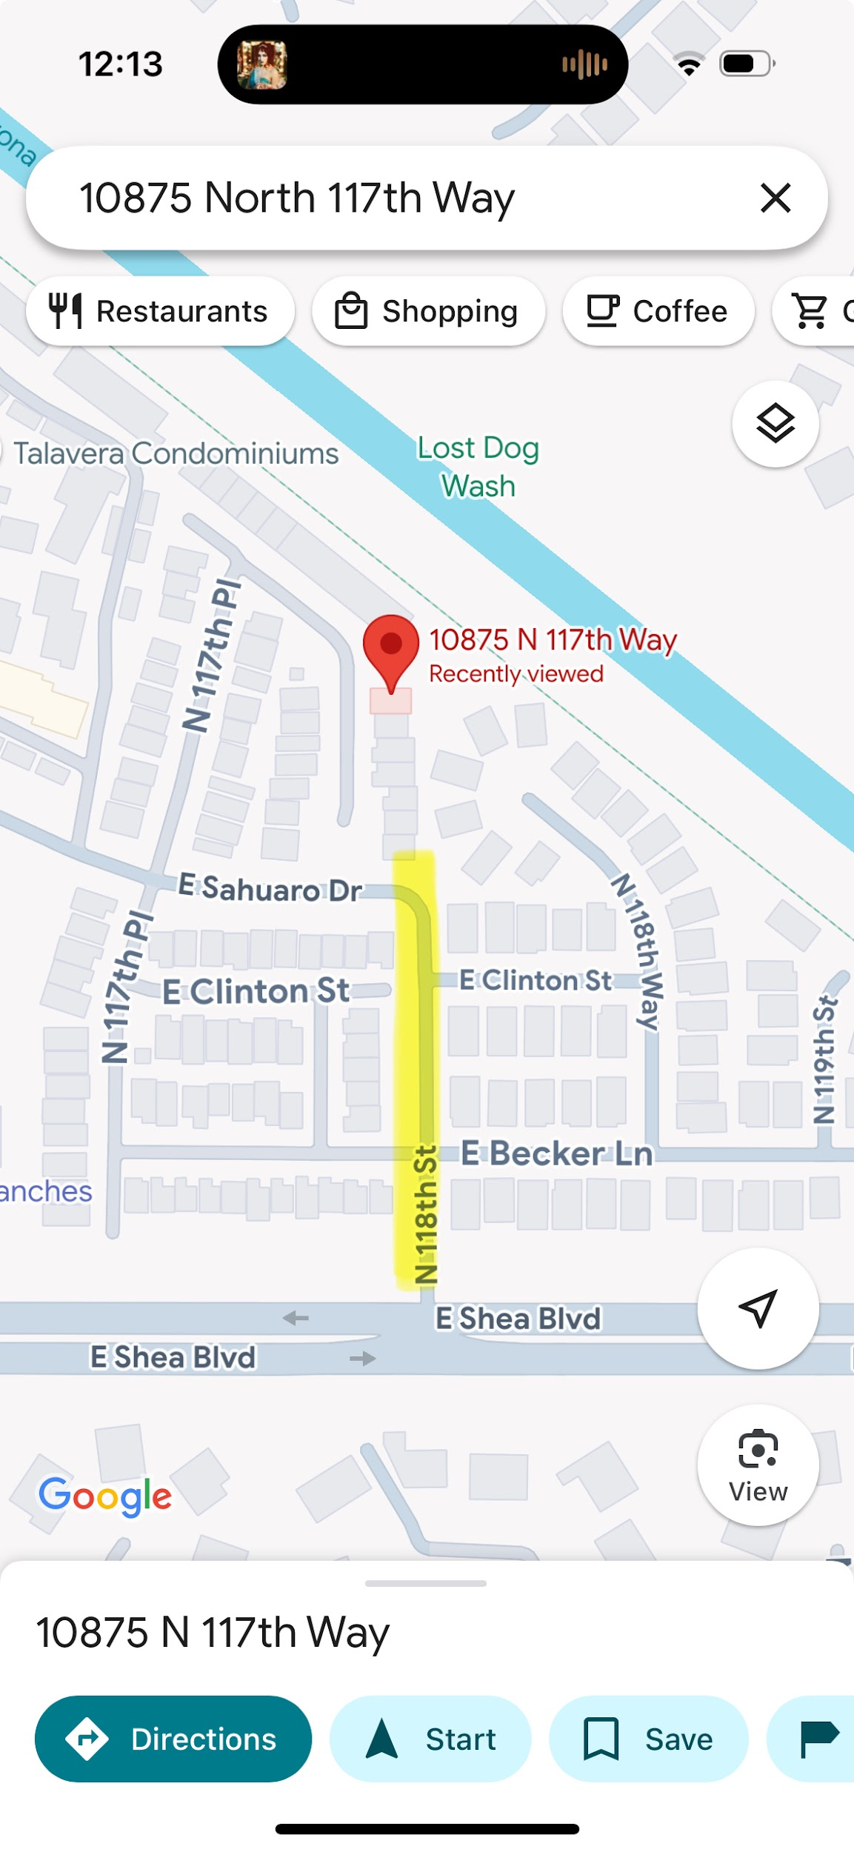

**Guest Guide:**<https://docs.google.com/document/d/1leqHeim7uCGWtn0WSqluGpK51iEnxtEEPemk8kNGby0/edit>

**Guest Messaging Guide:**

<https://docs.google.com/document/d/16qBEfvNvXssen6w8ewwPsNpatKLuUd0dn8dHKpjoDGA/edit>

**Patio fan and lights not working:**

Sometimes the outlet gets tripped and it needs the ground fault pushed in. Then plug it back in and it should work. The lights have about 9 settings. There is a little black button on the plug that you push for each light setting for blinking etc. After about 6 pushes they should stay on steady.

**Good to know**

* 2 bedroom plus Murphy bed in front foyer (no door, but we have a curtain for privacy. This is also clearly described in the listing)
* Cushion in backyard need to be brought in in between guests (Notes for cleaner)
* May-Oct: monthly pest control needs to come inside
* Regular fireplace
* **OUTSIDE PATIO LIGHTS**: The lights on the patio, are plugged into the outlet that is beside the couch outside. Sometimes when you plug them in you have to reset the outlet. Once they are on about 6 to 7 clicks they will stay steady, they have different settings, it's a little push button on the part that plugs into outlet.

**Trash Info**

* Trash day is Tuesday Morning (black bin)
* Recycle day is Thursday (pink bin)
* Bins should be taken to the street Monday and Wednesday evenings.
* Bins should be returned and stored in the garage.

**Owner Info**

Renae Lovett

renae_lovett@hotmail...

+1 207-756-0856

Scott Lovett

+1 207-756-5170

# Property Inspection Log:

**Date of Notes:** XX

**Next Inspection Scheduled:** XX

* XX
* XX

# Restock strategy:

* W&G?
* Any special items different to our standard?

# Guest Access

* **Access Code:**
  + **Schlage Smart Lock:** A unique code generated for each guest (access Smartlock in Hospitable “Devices”)
  + **Backup Key / Lock out strategy:**
    - XXX
* **Garage access:** 
  + xxx
* **Cleaning closet:**

# Wi-Fi Information

* **Network Name:** XX
* **Password:** XX
* **Notes:**
  + Internet provider
  + **Account Email:** XX
  + **Account Number:** XX

# House Notes

### Guest Guide

* XX
* **Guest Messaging Guide:** [Google Doc Link](https://docs.google.com/document/d/16qBEfvNvXssen6w8ewwPsNpatKLuUd0dn8dHKpjoDGA/edit)

### Good to know

* Ie: Where something is that is often misplaced by guests, how to work something that is often asked about

### Trash & Recycling:

* XX
* XX
* *Auto message is scheduled in Hospitable to send to guests ______ night to take out the trash

### 

### AC Filter Size & change frequency:

* XX

### Breaker Box:

* Breaker box is located ________

### 

### Mail:

* XX
* XX

### 

### Commonly asked about amenities:

* **Firepit:** XX
* **Grill:** Propane or charcoal?
* **Backyard:** Fully fenced? What amenities?
* **Pack n play:** Location. Sheets?
* **Coffee maker**: Type? Type of coffee provided?
* **TV:** 
  + Re Cox Cable trouble shooting from Renae: There is a slender black box, each TV has one behind it...both the blue and green light should be on. If they are not on, they should only have to unplug this box, plug it back in and it should reboot itself. Sometimes for unknown reasons it will drop the internet signal so if both lights are not on that should fix the issue
  + It’s common for this to happen if it’s been a a while without being turned on.

### Pet Policy:

* XX

# Smart Home Devices:

### 

### Thermostat:

* + **Device:** XX
  + **Login:** XX
  + **Password:** XX

### 

### Security Camera:

* **Location**
* **Access:**
  + Access on a phone/iPad app
  + Log in info:

# Cleaning:

* **Primary Cleaner:** XX
* **Scheduling:** XX
* **Extra Jobs:** XX

# Handyman / Maintenance:

* **XX**
  + XX
* **Landscaping:**
  + XX
* **Pest Control**
  + XX
* **HVAC**
  + XX
* **Plumbing**
  + XX

# 